PROGRAM ASSESSMENT REPORT
Assessment of Student Learning, Annual Program Report 2021-2022
1

Program/Department:

School:

Director/Dean:

Degree:

Years | Program Outcomes Assessed for this Academic Year | Project for the Year
Academic Year 0: 2020 - 2021
Academic Year 1: 2021 - 2022
Academic Year 2: 2022 - 2023
Academic Year 3: 2023 - 2024
Academic Year 4: 2024 - 2025
Academic Year 5: 2025 - 2026
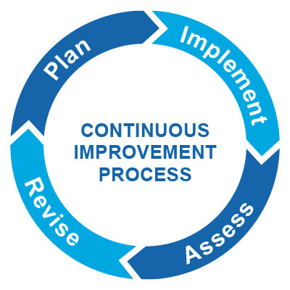

Section 1: Plan (Please Complete in the Fall)

- What was working for your program last year?
- What was not working for your program last year?
- What kind of project can you work on to improve student performance on your program learning outcomes?
- What program learning outcomes would be the focus of this project?
- Which Institutional Learning Outcome may be tangentially or indirectly involved?

Section 2: Implement (Please Complete in the Winter/Spring)

- What evidence will you collect to assess in this project?
- Who is your sample?
- What are some potential biases that could be a part of this assessment project? Are there any ways that we could minimize biases?
- What kind of tool are you using for your assessment (e.g., rubric or scoring guide)? Describe the elements of this tool.
- Will assessment be blind? If not, consider that this may be a weakness.
- Who will be involved in the assessment plan?

Section 3: Assess (Suggestion: Winter/Spring)

- What were the results of the academic assessment process?
- What were some strengths? What were some weaknesses?
- What surprised you?
- What were some areas that the program needs to continue to watch?

Section 4: Revise (Suggestion: Summer)

- Where are you improving your program?
- What did your adjuncts/faculty/advisory board members think of the results? What were their suggestions?
- How will you use these results to improve your academic program/curriculum?

.

